|  |  |  |  |  |  |  |  |
| --- | --- | --- | --- | --- | --- | --- | --- |
| PROD Environment : OLSS Web Server IP : 192.168.140.21 OLSS Database Server IP: OLSS Job File Server IP :DRC Environment : OLSS Web Server IP : 172.24.1.42 OLSS Database Server IP: OLSS Job File Server IP : | | | | DSF Project Name : **Operating Lease Support System**  Name : Fajar Solihin Putra  Department : BSI  Date : 11 September 2019 | | | |
| |  |  |  |  | | --- | --- | --- | --- | | **Release Form** | **SIT Reference** | Classification Critical  High  Medium  Low | Category New Request  Enhancement Major  Enhancement Minor  Correction | | No. : 20191109-01  Date : 11 September 2019  Ticket No : **P0176236**  CR No : **C0023832** | 1. SIT Environment: 10.1.1.38/olss_fixintg  2. SIT Date : 10 September 2019  3. PIC : Sonny Ariady | | | | | | | | |
| **Subject : Fixing Connection Problem in Management Module** | | | | | | | |
| **Description of Change**  Preventive action related integration with MFAPPL – Monitoring Payment Schedule. When user open Management Module – Monitoring Payment Schedule Integration, it will show error **Connection problem! An error occurred on the server. Please try again in a few minutes or contact your administrator.** And the data of Payment Schedule Integration from MFAPPL are not showing.  **Root cause:**  There are some data structure that changes in MFAPPL so OLSS data structure must be changed.  **Fixing:**   1. Change data structure **Dsf.OLSS.Service - BAST.designer**:    * Field LastModifiedDate data type change from **byte** to **System.DateTime**    * **OverdueAMT** and **Billing Total** data type change from **NOT allow NULL** to **allow NULL**    * Add condition if Idtb_bil_payschedule is NULL. 2. Change data structure **Dsf.OLSS.Service - BAST.xsd**:    * Change parameter **AllowDbNull** from **False** to **True**.    * Change **ConnectionRef** to be the same as app.config/ web.config    * Add condition **minOccurs = 0** in table **tb_BIL_PaySchedule**    * Delete condition **unique name**  for Primary Key in table **tb_BIL_PaySchedule** 3. Change data structure **Dsf.OLSS.Service.csproj**:    * Change **App.Config** to be configurable   **BEFORE:**  Users cannot see open Management Module – Monitoring Payment Schedule Integration, showing error **Connection problem! An error occurred on the server. Please try again in a few minute or contact your administrator.**  **AFTER:**  Users can see data in Management Module – Monitoring Payment Schedule Integration. | | | **Release Scenario to Production:**   |  |  |  |  | | --- | --- | --- | --- | | **No.** | **Task** | **Duration** | **PIC** | | **1.** | Stop IIS in web server (192.168.140.21) | **5 minutes** | **Firmansyah** | | **2.** | Change connection string in Dsf.Service.dll.config | **5 minutes** | **Firmansyah** | | **3.** | Deploy .net file | **15 minutes** | **Firmansyah** | | **4.** | Start IIS in web server (192.168.140.21) | **5 minutes** | **Firmansyah** |   **After Release to Production:**   |  |  |  |  | | --- | --- | --- | --- | | **No.** | **Task** | **Duration** | **PIC** | | **1.** | Login to OLSS Web Application and go to Management Module – Monitoring Payment Schedule Integration | **5 minutes** | **Marion** |   **Release Scenario to DRC:**   |  |  |  |  | | --- | --- | --- | --- | | **No.** | **Task** | **Duration** | **PIC** | | **1.** | Stop IIS in web server (172.24.1.42) | **5 minutes** | **Aryo Budi** | | **2.** | Change connection string in Dsf.Service.dll.config | **5 minutes** | **Aryo Budi** | | **3.** | Deploy .net file | **15 minutes** | **Aryo Budi** | | **4.** | Start IIS in web server (172.24.1.42) | **5 minutes** | **Aryo Budi** |   **After Release to DRC:**   |  |  |  |  | | --- | --- | --- | --- | | **No.** | **Task** | **Duration** | **PIC** | | **1.** | Login to OLSS Web Application and go to Management Module – Monitoring Payment Schedule Integration | **5 minutes** | **Marion** | | | | | |
| **Consequence if not done:**  Users cannot monitor data in Management Module – Monitoring Payment Schedule Integration. | | | **Rollback Plan**  *(If the release activity fail)*  Replace the files from backup folder in SVN with URL [https://172.17.25.33/svn/OPR/DSF/OLS Operation/Documents/Change Request/CR2019_XXX P0176236 C0023832 - Fixing Connection Problem in Management Module](https://172.17.25.33/svn/OPR/DSF/OLS%20Operation/Documents/Change%20Request/CR2019_XXX%20P0176236%20C0023832%20-%20Fixing%20Connection%20Problem%20in%20Management%20Module) folder. | | | | |
| **File Name & SQL Script to Release:**   * **Dsf.Olss.Service.dll** | | | **Release Plan**  **Date: 11 September 2019**  **Time: 17:00** | | | **Release Actual**  **Date:**  **Time:** | |
| **Before Release** | | | | | **After Release** | | |
| Requested by | Approved by | Approved by | | | Checked by Requester | | Checked by Superior |
| Date: __ ___ ____ | Date: __ ___ ____ | Date: __ ___ ____ | | | Date: __ ___ ____ | | Date: __ ___ ____ |
|  |  |  | | |  | |  |
| Fajar Solihin Putra | Devilosa Indra Kamal | Valentinus A. Bay Meo | | | Fajar Solihin Putra | | Devilosa Indra Kamal |

**ATTACHMENT**

**Screenshoot from Monitor Payment Schedule Integration Before Deployment**

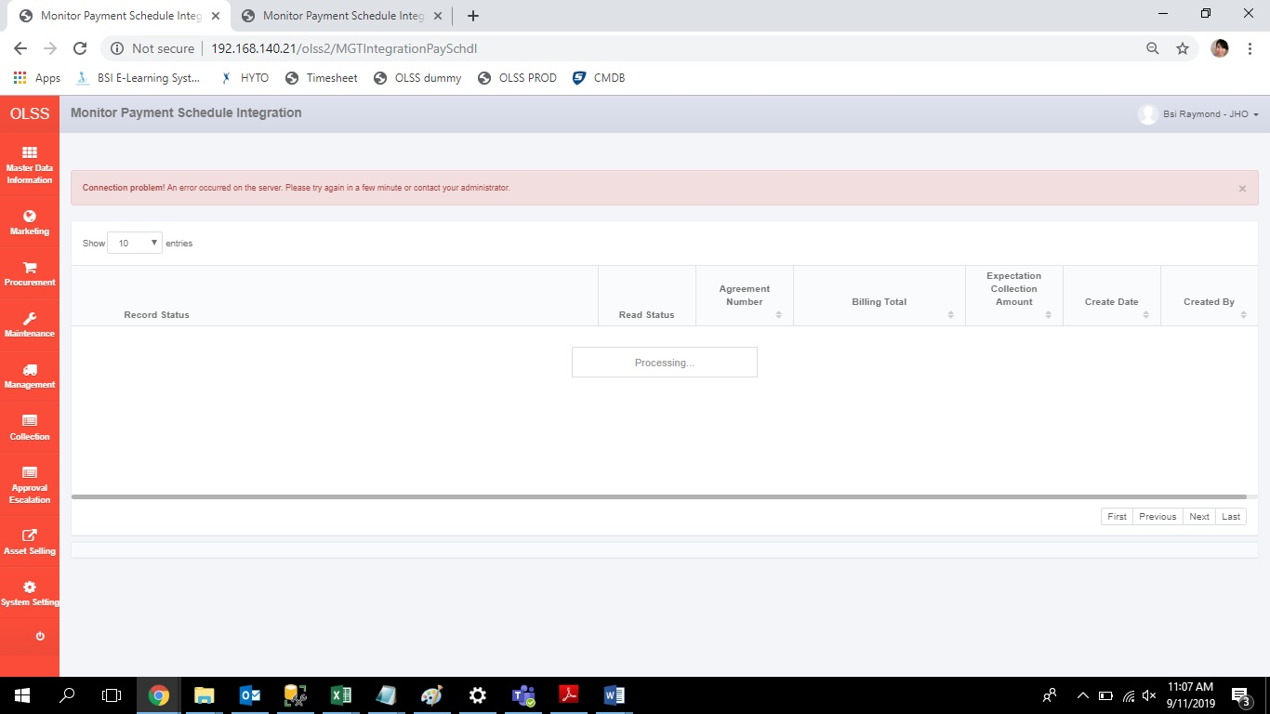

**Screenshoot from Monitor Payment Schedule Integration After Deployment**

